**Emergency Eye Wash**

(Instruction Book)

**Model: UK301**

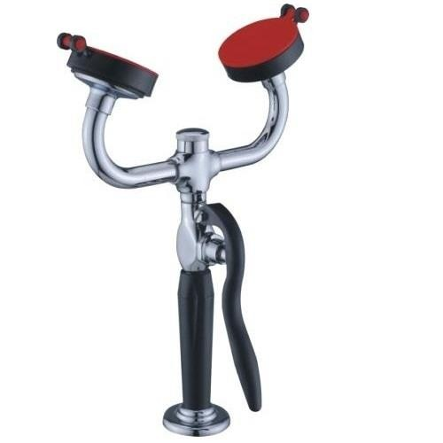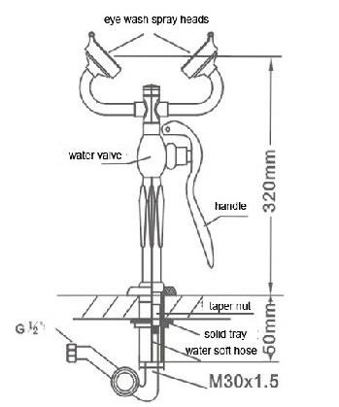

**\*Usage**

**SAFETY EYE WASH**

Security and the labor protection necessary equipment, is the contact plant acid, the alkali,

the organic matter and other is virulent, the corrosive situation necessary emergency protection facility.

When has the accident, through the rapid flushing, reduces the injury degree to is lowest.

**\*The product performance characteristic**

- Floors install the way, usually lays aside to the table, when urgent use may pull out at will, easy to

operate.

- Washes the eye nozzle: Uses does not aid combustion a PC material quality casting body forming manufacture, has had the follicle cotton and kapok and the dustproof function, above dust cap usually

may dustproof, when use may flushing out by water on any time, and reduces suddenly opens when

the short high hydraulic pressure, avoids flushing the wound eye.

- Controls the water valve to use the brass manufacture, after chrome plating processing, outward appearance artistic natural, the valve may the automatic

Shut-off, the seal be reliable.

- Equipped with the flow control valve, may act according to supplies water the current capacity which the pressure setting person eye is suitable.

- Water supplies hoses: Uses the 1500mm long stainless steel hose.

**\*Technical parameter:**

|  |  |  |  |  |
| --- | --- | --- | --- | --- |
| **The pressure grade (MPa)** | | | **Flow L/min** | **Suitable terms** |
| Normal pressure | Seal pressure | Working pressure | ≥11.4 | The normal temperature pure water or conforms to the hygienic standard water used |
| 0.4 | 0.45 | 0.2-0.4 |

**\*The installment explained**

- Will fix the tray installment to fix in the table.

- Will supply water the hose cone-shaped nut to carry (internal installation cushion) to pass through from the fixed tray, with will control water valve G l/2” the "attachment spot connection.

- Will supply water hose G l/2" to lock the nut to carry (internal installation cushion) and the water

supply pipeline connection.

**\*Operating instructions**

- When needs to wash the eye, may extract and get hold of the handle at will according to the need

namely for to open, the pine opens the handle automatic shut-off.

- Current capacity regulating valve adjustment method: Washes among eye double nozzle two for to wash the eye current capacity regulating valve. Washes the eye nozzle the current capacity to control

by the current capacity regulating valve. Leaves the plant when has debugged. When as a result of the

water supply pressure, the current capacity difference, installs may the scene adjustment, adjusts the person eye to be suitable the current capacity. Adjustment method: Turns on lathe the crown safety mask, with a character screwdriver adjustment regulating valve stem, clockwise revolves, the current capacity reduces. The counter clockwise revolves, the current capacity increases.

- The hose curving should allow nature to take its course, should not make an effort to reverse or to be curving.

**\*The common breakdown and removes:**

|  |  |  |  |
| --- | --- | --- | --- |
| **Serial**  **No.** | **Common breakdown** | **Happen reason** | **Remove the method** |
| 1 | Spray head water leakage current capacity slightly to enter | The water to have the internal organs | Spurts the piece hole to stop up dismantles spurts the piece to clean the dirty |
| 2 | Closure not to be lax (dripping of a water clock) | Enter the water to have the internal organs, the gasket dismantles the card or the damage the lid | Clean or replaces the gasket |
| 3 | Hoses connector water leakage | Connect the place cushion damage | Replacement cushion |

**\*Maintain for the long-term maintenance valve body artistic suggestion according to the following method:**

- Please pass through the commonly used clear water to float only, soft cloth cleans wipes does.

- The elimination surface dirt, please use not to have the abrasive action the liquid cleanser to remove the dirt, after cleanly finished, then uses the clear water flushing cleanser, with soft cloth wipes does.

**\*Takes inventory the fitting:**

After operates the box please according to the below detailed list inventory fitting quantity, the

inspection has in the transportation the damage, if has in the question or the quantity insufficiency, please immediately relates with this company local dealer or this company, you will be able to obtain

satisfaction the answer.

|  |  |  |
| --- | --- | --- |
| **Serial No.** | **Spare parts name** | **Quantity** |
| 1 | Controls water valve partial | 1 Set |
| 2 | Fixed trays partial | 1 Set |
| 3 | Water supplies hose partial | 1 Set |
| 4 | Spare parts (gasket) | 1 pc. |